ARM Instruction syntax:
Mnemonic <Destination> <Source(s)>

DATA PROCESSING INSTRUCTIONS

Move Instructions
Move is the simplest ARM instruction. It copies N into a destination register Rd, where
N is a register or immediate value. This instruction is useful for setting initial values and
transferring data between registers.

Syntax: <instruction>{<cond>}{S} Rd, N

MOV Move a 32-bit value into a register Rd = N
MVN move the NOT of the 32-bit value into a register Rd = ∼N

eg: MOV r7,r5

Barrel Shifter Operations
A unique and powerful feature of the ARM processor is the ability to shift the 32-bit binary
pattern in one of the source registers left or right by a specific number of positions before
it enters the ALU.

Eg: MOV r7, r5, LSL #2

The five different shift operations that you can use within the barrel shifter are:
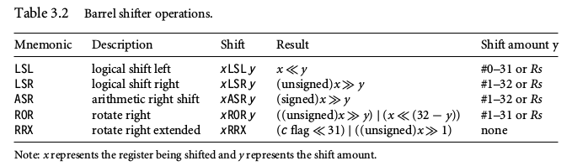
Arithmetic Instructions
The arithmetic instructions implement addition and subtraction of 32-bit signed and
unsigned values.

Syntax: <instruction>{<cond>}{S} Rd, Rn, N

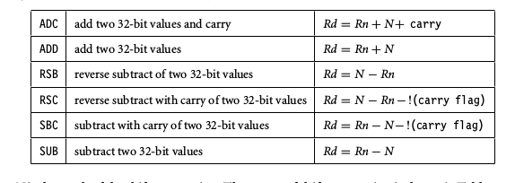

Barrel Shifter with Arithmetic Instructions

ADD r0, r1, r1, LSL #1

Register r1 is first shifted one location to the left to give the value of twice r1. The ADD
instruction then adds the result of the barrel shift operation to register r1. The final result
transferred into register r0 is equal to three times the value stored in register r1.

Logical Instructions
Logical instructions perform bitwise logical operations on the two source registers.

Syntax: <instruction>{<cond>}{S} Rd, Rn, N
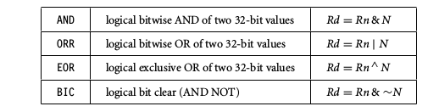
Comparison Instructions
The comparison instructions are used to compare or test a register with a 32-bit value.
They update the cpsr flag bits according to the result, but do not affect other registers.
After the bits have been set, the information can then be used to change program flow by
using conditional execution.

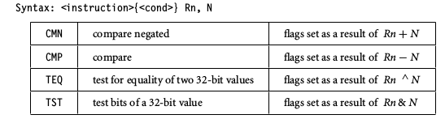
Multiply Instructions
The multiply instructions multiply the contents of a pair of registers and, depending upon
the instruction, accumulate the results in with another register. The long multiplies accu-
mulate onto a pair of registers representing a 64-bit value. The final result is placed in
a destination register or a pair of registers.

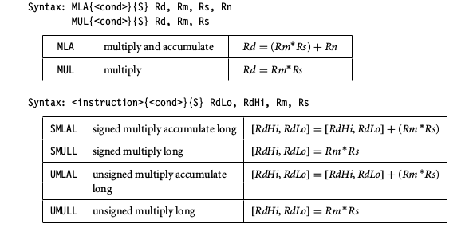

The number of cycles taken to execute a multiply instruction depends on the processor
implementation. For some implementations the cycle timing also depends on the value
in Rs.

BRANCH INSTRUCTIONS

A branch instruction changes the flow of execution or is used to call a routine. This type
of instruction allows programs to have subroutines, if-then-else structures, and loops.

The change of execution flow forces the program counter pc to point to a new address.
The ARMv5E instruction set includes four different branch instructions.

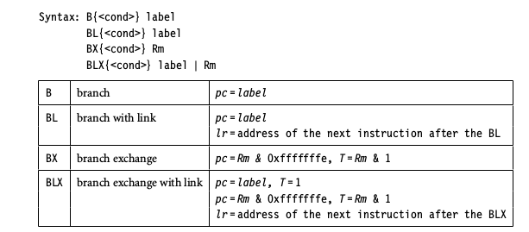
The address label is stored in the instruction as a signed pc-relative offset and must be
within approximately 32 MB of the branch instruction. T refers to the Thumb bit in the
cpsr. When instructions set T, the ARM switches to Thumb state.

The BX instruction uses an absolute address stored in register Rm. It is primarily used to branch to and from Thumb code.
The T bit in the cpsr is updated by the least significant bit of the branch register. Similarly the BLX
instruction updates the T bit of the cpsr with the least significant bit and additionally sets the link register with the return address.

LOAD-STORE INSTRUCTIONS

Load-store instructions transfer data between memory and processor registers. There are
three types of load-store instructions: single-register transfer, multiple-register transfer,
and swap.

Single-Register Transfer
These instructions are used for moving a single data item in and out of a register. The
datatypes supported are signed and unsigned words (32-bit), halfwords (16-bit), and bytes.

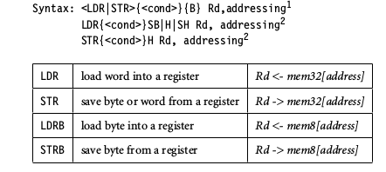

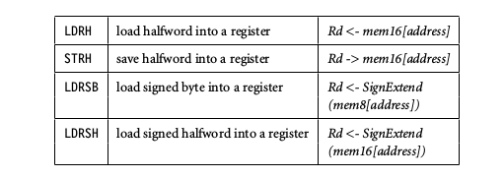
LDR and STR instructions can load and store data on a boundary alignment that is the same
as the datatype size being loaded or stored. For example, LDR can only load 32-bit words on
a memory address that is a multiple of four bytes—0, 4, 8, and so on.

Single-Register Load-Store Addressing Modes
The ARM instruction set provides different modes for addressing memory. These modes
incorporate one of the indexing methods: preindex with writeback, preindex, and postindex.

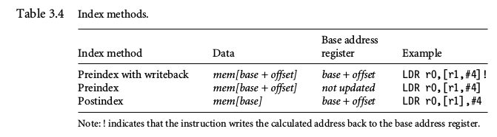
Preindex with writeback calculates an address from a base register plus address offset and
then updates that address base register with the new address. In contrast, the preindex offset
is the same as the preindex with writeback but does not update the address base register.
Postindex only updates the address base register after the address is used. The preindex
mode is useful for accessing an element in a data structure. The postindex and preindex
with writeback modes are useful for traversing an array.

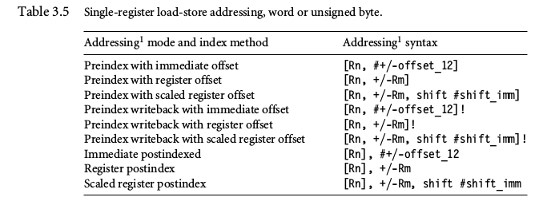
The addressing modes available with a particular load or store instruction depend on
the instruction class. Table 3.5 shows the addressing modes available for load and store of
a 32-bit word or an unsigned byte.
A signed offset or register is denoted by “+/−”, identifying that it is either a positive or
negative offset from the base address register Rn. The base address register is a pointer to
a byte in memory, and the offset specifies a number of bytes.
Immediate means the address is calculated using the base address register and a 12-bit
offset encoded in the instruction. Register means the address is calculated using the base
address register and a specific register’s contents. Scaled means the address is calculated
using the base address register and a barrel shift operation.

Multiple Register Transfer
Load-store multiple instructions can transfer multiple registers between memory and the
processor in a single instruction. The transfer occurs from a base address register Rn pointing
into memory. Multiple-register transfer instructions are more efficient from single-register
transfers for moving blocks of data around memory and saving and restoring context and
stacks.

Load-store multiple instructions can increase interrupt latency. ARM implementations
do not usually interrupt instructions while they are executing. For example, on an ARM7
a load multiple instruction takes 2 + Nt cycles, where N is the number of registers to load
and t is the number of cycles required for each sequential access to memory. If an interrupt
has been raised, then it has no effect until the load-store multiple instruction is complete.

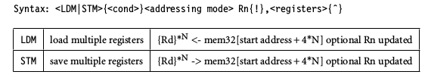
STACK OPERATIONS

The ARM architecture uses the load-store multiple instructions to carry out stack
operations. The pop operation (removing data from a stack) uses a load multiple instruction;
similarly, the push operation (placing data onto the stack) uses a store multiple instruction.
When using a stack you have to decide whether the stack will grow up or down in
memory. A stack is either ascending (A) or descending (D). Ascending stacks grow towards
higher memory addresses; in contrast, descending stacks grow towards lower memory
addresses.

When you use a full stack (F), the stack pointer sp points to an address that is the last
used or full location (i.e., sp points to the last item on the stack). In contrast, if you use an
empty stack (E) the sp points to an address that is the first unused or empty location (i.e., it
points after the last item on the stack).

ARM has specified an ARM-Thumb Procedure Call Standard (ATPCS) that defines how
routines are called and how registers are allocated. In the ATPCS, stacks are defined as being
full descending stacks. Thus, the LDMFD and STMFD instructions provide the pop and push
functions, respectively.
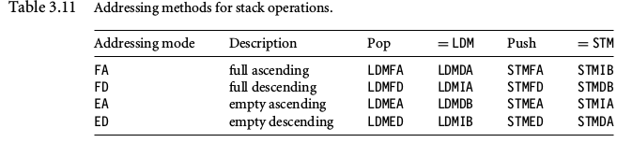
When handling a checked stack there are three attributes that need to be preserved: the
stack base, the stack pointer, and the stack limit. The stack base is the starting address of the
stack in memory. The stack pointer initially points to the stack base; as data is pushed onto
the stack, the stack pointer descends memory and continuously points to the top of stack.
If the stack pointer passes the stack limit, then a stack overflow error has occurred.

SWAP INSTRUCTION
The swap instruction is a special case of a load-store instruction. It swaps the contents of
memory with the contents of a register. This instruction is an atomic operation—it reads
and writes a location in the same bus operation, preventing any other instruction from
reading or writing to that location until it completes.

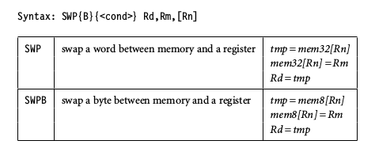

SOFTWARE INTERRUPT INSTRUCTION

A software interrupt instruction (SWI) causes a software interrupt exception, which provides
a mechanism for applications to call operating system routines.

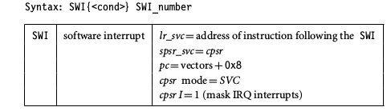

When the processor executes an SWI instruction, it sets the program counter pc to the
offset 0x8 in the vector table. The instruction also forces the processor mode to SVC, which
allows an operating system routine to be called in a privileged mode.

Each SWI instruction has an associated SWI number, which is used to represent
a particular function call or feature.
Since SWI instructions are used to call operating system routines, you need some form
of parameter passing. This is achieved using registers.
Code called the SWI handler is required to process the SWI call. The handler obtains
the SWI number using the address of the executed instruction, which is calculated from the
link register lr.
The SWI number is determined by
SWI_Number = <SWI instruction> AND NOT(0xff000000)
Here the SWI instruction is the actual 32-bit SWI instruction executed by the processor.

PSR Instructions

The ARM instruction set provides two instructions to directly control a program status
register (psr). The MRS instruction transfers the contents of either the cpsr or spsr into
a register; in the reverse direction, the MSR instruction transfers the contents of a register
into the cpsr or spsr. Together these instructions are used to read and write the cpsr and spsr.
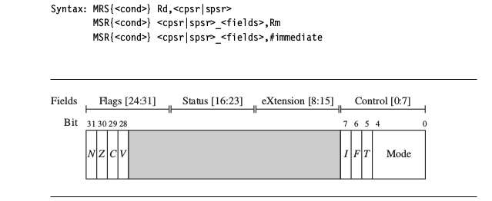

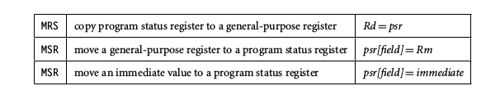

COPROCESSOR INSTRUCTIONS

Coprocessor instructions are used to extend the instruction set. A coprocessor can either
provide additional computation capability or be used to control the memory subsystem
including caches and memory management. The coprocessor instructions include data
processing, register transfer, and memory transfer instructions.

Syntax:
CDP{<cond>} cp, opcode1, Cd, Cn {, opcode2}
<MRC|MCR>{<cond>} cp, opcode1, Rd, Cn, Cm {, opcode2}
<LDC|STC>{<cond>} cp, Cd, addressing

In the syntax of the coprocessor instructions,
the cp field represents the coprocessor number between p0 and p15.
The opcode fields describe the operation to take place on the coprocessor.
The Cn, Cm, and Cd fields describe registers within the coprocessor.

The coprocessor operations and registers depend on the specific coprocessor you are
using. Coprocessor 15 (CP15) is reserved for system control purposes, such as memory
management, write buffer control, cache control, and identification registers.

CDP coprocessor data processing—perform an operation in a coprocessor
MRC MCR coprocessor register transfer—move data to/from coprocessor registers
LDC STC coprocessor memory transfer—load and store blocks of memory to/from a coprocessor

Loading Constants

To aid programming there are two pseudoinstructions to move a 32-bit value into
a register.
Syntax: LDR Rd, =constant
ADR Rd, label

LDR load constant pseudoinstruction Rd = 32-bit constant
ADR load address pseudoinstruction Rd = 32-bit relative address

Compilers and assemblers use clever techniques to avoid
loading a constant from memory. These tools have algorithms to find the optimal number
of instructions required to generate a constant in a register and make extensive use of
the barrel shifter. The LDR pseudoinstruction either inserts an MOV or MVN instruction
to generate a value (if possible) or generates an LDR instruction with a pc-relative address
to read the constant from a literal pool—a data area embedded within the code.

ARMv5E Instructions

ARMv5E provides greater flexibility and efficiency when manipulating 16-bit values,
which is important for applications such as 16-bit digital audio processing.
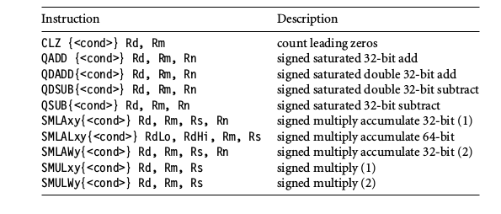

CLZ - The count leading zeros instruction counts the number of zeros between the most significant
bit and the first bit set to 1.
eg: CLZ r0, r1

Saturated Arithmetic
Normal ARM arithmetic instructions wrap around when you overflow an integer value.
using the ARMv5E instructions you can saturate the result—once the highest
number is exceeded the results remain at the maximum value of 0x7fffffff. This avoids
the requirement for any additional code to check for possible overflows.

Instruction Saturated calculation
QADD Rd = Rn + Rm
QDADD Rd = Rn + (Rm ∗ 2)
QSUB Rd = Rn − Rm
QDSUB Rd = Rn − (Rm ∗ 2)

Multiply Instructions

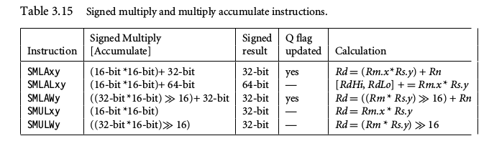
SMLATB r4, r1, r2, r3
The instruction multiplies the top 16 bits of register r1 by the bottom 16 bits of register r2.
It adds the result to register r3 and writes it to destination register r4.

Conditional Execution

Most ARM instructions are conditionally executed—you can specify that the instruction
only executes if the condition code flags pass a given condition or test. By using conditional
execution instructions you can increase performance and code density.
The condition field is a two-letter mnemonic appended to the instruction mnemonic.
The default mnemonic is AL, or always execute.

Conditional execution reduces the number of branches, which also reduces the number
of pipeline flushes and thus improves the performance of the executed code. Conditional
execution depends upon two components: the condition field and condition flags. The
condition field is located in the instruction, and the condition flags are located in the cpsr.

THUMB INSTRUCTION SET

Thumb encodes a subset of the 32-bit ARM instructions into a 16-bit instruction set space. Since Thumb has higher performance than ARM on a processor with a 16-bit data bus, but lower performance than ARM on a 32-bit data bus, use Thumb for memory-constrained systems.

Thumb has higher code density—the space taken up in memory by an executable
program—than ARM. For memory-constrained embedded systems, for example, mobile
phones and PDAs, code density is very important. Cost pressures also limit memory size,
width, and speed.

On average, a Thumb implementation of the same code takes up around 30% less
memory than the equivalent ARM implementation. Even though the Thumb implementation uses more instructions, the overall memory footprint is reduced. Code density was the main driving force for the Thumb instruction set.

The limited space available in 16 bits causes the barrel
shift operations ASR, LSL, LSR, and ROR to be separate instructions in the Thumb ISA.

In Thumb state, you do not have direct access to all registers. Only the low registers r0
to r7 are fully accessible. The higher registers r8 to r12 are only accessible with MOV, ADD, or CMP instructions. CMP and all the data processing instructions that operate on low registers update the condition flags in the cpsr. There is no direct access to the cpsr or spsr. In other words, there are no MSR- and MRS-equivalent Thumb instructions.

ARM-Thumb Internetworking
ARM-Thumb interworking is the name given to the method of linking ARM and Thumb
code together for both assembly and C/C++. It handles the transition between the two
states. Extra code, called a veneer, is sometimes needed to carry out the transition. ATPCS
defines the ARM and Thumb procedure call standards.

To call a Thumb routine from an ARM routine, the core has to change state. This state
change is shown in the T bit of the cpsr. The BX and BLX branch instructions cause a switch
between ARM and Thumb state while branching to a routine. The BX lr instruction returns
from a routine, also with a state switch if necessary.

The ARM BX instruction enters Thumb state only if bit 0 of the address in
Rn is set to binary 1; otherwise it enters ARM state. The Thumb BX instruction does
the same.
Unlike the ARM version, the Thumb BX instruction cannot be conditionally executed.

